**Introduction**

In today's fast-paced financial markets, making informed investment decisions is crucial for maximizing returns and minimizing risks. With the abundance of available data and advancements in machine learning techniques, predictive modeling has become an indispensable tool for investors and financial analysts alike. This report presents an in-depth analysis of stock market price prediction using machine learning algorithms.

The primary objective of this report is to develop and evaluate machine learning models capable of forecasting stock prices accurately. We leverage historical stock market data to train and test predictive models, aiming to predict future stock prices based on past market behavior. By harnessing the power of computational algorithms and statistical techniques, we seek to uncover patterns and trends within the data that can guide investment strategies and decision-making processes.

The report begins by introducing the dataset used for analysis, detailing its sources and characteristics. We then delve into data preprocessing steps, including feature engineering and data transformation techniques, aimed at enhancing the predictive power of the models. Next, we explore various machine learning algorithms, ranging from traditional linear regression to advanced ensemble methods, to identify the most suitable model for stock price prediction.

Following model development, we evaluate the performance of each algorithm using appropriate evaluation metrics, such as Mean Squared Error (MSE) and Root Mean Squared Error (RMSE). Additionally, we conduct comparative analyses to assess the strengths and weaknesses of different models and highlight areas for improvement.

The findings and insights presented in this report are intended to assist investors, financial institutions, and stakeholders in making more informed decisions in the dynamic and complex world of financial markets. By leveraging data-driven approaches and predictive analytics, we aim to empower individuals and organizations to navigate the uncertainties of the stock market with confidence and clarity.

In summary, this report serves as a comprehensive exploration of stock market price prediction using machine learning techniques, offering valuable insights and practical recommendations for enhancing investment strategies and achieving financial goals in an increasingly competitive landscape.

**Literature Review**

Predicting stock market prices has been a topic of interest for researchers, investors, and financial analysts for decades. Numerous studies have explored various approaches and techniques for forecasting stock prices, ranging from traditional econometric models to sophisticated machine learning algorithms.

Early research in the field of stock market prediction often relied on econometric models such as autoregressive integrated moving average (ARIMA) and generalized autoregressive conditional heteroskedasticity (GARCH) models. These models attempted to capture the time series dynamics and volatility patterns of stock prices based on historical data (Campbell et al., 1997; Engle, 1982). While these models provided valuable insights into market dynamics, their reliance on linear relationships and assumptions about data distribution limited their predictive accuracy, especially in volatile and non-linear market conditions.

In recent years, advancements in computational technology and the availability of vast amounts of financial data have spurred the development of machine learning-based approaches for stock market prediction. Machine learning algorithms, such as support vector machines (SVM), random forests, and neural networks, offer the flexibility to capture complex non-linear relationships and patterns within the data (Huang et al., 2005; Kim et al., 2003; Shen et al., 2013). These models leverage features extracted from historical stock prices, trading volumes, and other financial indicators to forecast future price movements with higher accuracy and robustness.

Several studies have demonstrated the effectiveness of machine learning techniques in stock market prediction across different time horizons and asset classes. For example, Zhang et al. (2019) applied long short-term memory (LSTM) neural networks to predict stock prices, achieving superior performance compared to traditional models. Similarly, Liu et al. (2020) employed gradient boosting machines (GBM) to forecast stock returns, demonstrating improved predictive accuracy and stability.

Despite the advancements in predictive modeling, challenges remain in accurately forecasting stock prices due to the inherent volatility and complexity of financial markets. Factors such as market sentiment, geopolitical events, and macroeconomic indicators can influence stock price movements in unpredictable ways, making it difficult to develop models that consistently outperform the market.

In summary, the literature on stock market prediction highlights the evolution from traditional econometric models to machine learning-based approaches. While machine learning techniques offer promising avenues for improving predictive accuracy, further research is needed to address the challenges associated with real-world market dynamics and enhance the robustness of predictive models.

1. **Methodology:  
   Introduction**
   * **Introduction to the methodology section provides a brief overview of its purpose and significance in research. It serves as a roadmap for the readers, outlining the systematic approach used to conduct the study and ensuring the reliability and validity of the research findings.**
2. **Research Design**
   * **Research design refers to the overall strategy or plan for conducting the study. It outlines the purpose and objectives of the research, guiding the selection of appropriate methods and techniques. For example, in a quantitative study on stock market prediction, the research design may involve developing machine learning models to forecast stock prices, aiming to achieve specific research objectives such as improving investment strategies or understanding market trends.**
3. **Data Collection**
   * **Data collection involves gathering relevant information or data for analysis. This may include collecting historical stock price data, financial indicators, and other relevant variables from sources such as financial databases or APIs. Preprocessing steps such as cleaning and transforming the data may be conducted to ensure its quality and usability.**
4. **Feature Engineering**
   * **Feature engineering refers to the process of creating new features or variables from existing data to improve model performance. In the context of stock market prediction, features such as moving averages, trading volumes, and technical indicators may be engineered from historical stock price data to capture market trends and patterns.**
5. **Model Development**
   * **Model development involves selecting and training machine learning algorithms to predict stock prices. Various algorithms such as linear regression, support vector machines, and neural networks may be considered, and the best-performing model is selected based on evaluation metrics such as Mean Squared Error (MSE) or Root Mean Squared Error (RMSE).**
6. **Evaluation Metrics**
   * **Evaluation metrics are used to assess the performance of predictive models. Common metrics include MSE, RMSE, and R-squared, which measure the accuracy, precision, and generalization capability of the models. These metrics provide insights into how well the models are performing and help identify areas for improvement.**
7. **Experimental Setup**
   * **Experimental setup involves dividing the data into training and testing sets, as well as applying cross-validation techniques to validate model performance and mitigate overfitting. Computational resources such as programming languages, libraries, and hardware may also be considered to ensure efficient model development and analysis.**
8. **Results Analysis**
   * **Results analysis entails interpreting the findings obtained from the experiments and comparing the performance of different models. This involves discussing the strengths, weaknesses, and insights gained from the experimental findings, as well as identifying any patterns or trends observed in the data.**
9. **Ethical Considerations**
   * **Ethical considerations involve addressing ethical issues related to the research, such as data privacy, potential biases, and implications for stakeholders and society. Measures should be taken to ensure ethical conduct throughout the research process, such as obtaining informed consent from participants and anonymizing sensitive data.**
10. **Conclusion**
    * **Conclusion summarizes the methodology section, highlighting key aspects of the research design, data collection, model development, and evaluation. It reflects on the strengths and limitations of the methodology employed and discusses potential implications for future research directions.**







**Coding Explanation:**

**Main function**

1. **Symbol Selection**
   * **The main function starts by defining a list of stock symbols (symbol_list). It then prompts the user to select a symbol from the list by displaying each symbol along with its index using a loop (for i, symbol in enumerate(symbol_list, 1)). The user is asked to enter the index of the symbol they want to analyze, and input validation ensures that the entered index is within the valid range.**
2. **Date Selection**
   * **After selecting the symbol, the user is prompted to enter the start and end dates for the analysis. The start date is entered in 'YYYY-MM-DD' format, while the end date can be left blank to default to today's date. If an end date is provided, it's also entered in 'YYYY-MM-DD' format.**
3. **Fetching Stock Data**
   * **Using the selected symbol and date range, the program fetches historical stock data using the yfinance library's download function. The fetched data is printed to the console, displaying details such as date, open, high, low, close, adjusted close, and volume.**
4. **Data Processing**
   * **The fetched stock data is then passed to the fetch_stock_data function, which further processes the data. This includes creating additional features such as moving averages (SMA_50, SMA_200) by using the create_features function.**
5. **Data Splitting**
   * **The processed data is split into features (X) and the target variable (y) using the split_data function. This prepares the data for training the machine learning model.**
6. **Train-Test Split**
   * **The features and target variables are further split into training and testing sets using the train_test_split function from the sklearn.model_selection module. The testing set size is set to 20% of the total data, and a random state is specified for reproducibility.**
7. **Model Training**
   * **The machine learning model is trained using the training data (X_train, y_train) with the train_model function. This function typically involves fitting the chosen model (e.g., Ridge regression) to the training data.**
8. **Model Evaluation**
   * **The trained model is evaluated using the testing data (X_test, y_test) to calculate the Mean Squared Error (MSE) with the evaluate_model function. This metric quantifies the performance of the model by measuring the average squared difference between predicted and actual values.**
9. **Making Predictions**
   * **The trained model is used to make predictions on the testing data (X_test) with the predict method. The predicted values are stored in the predictions variable.**
10. **Visualization**
    * **Finally, the visualize_results function is called to visualize the actual and predicted stock prices using line plots. This function typically displays two subplots: one for actual prices and another for predicted prices.**

**Graph Function:**

1. **Sampling Data:**
   * **sample_indices = random.sample(range(len(actual)), min(sample_size, len(actual))): This line randomly selects a subset of data points from the actual and predicted price arrays. It ensures that the number of selected data points does not exceed the specified sample_size or the total length of the arrays, whichever is smaller.**
2. **Extracting Data:**
   * **actual_prices = actual.values[sample_indices]: This line extracts the actual stock prices corresponding to the sampled indices from the actual array.**
   * **predicted_prices = predicted[sample_indices]: Similarly, this line extracts the predicted stock prices corresponding to the sampled indices from the predicted array.**
   * **indices = np.arange(len(actual_prices)): This line generates an array of indices corresponding to the sampled data points, which will be used for plotting.**
3. **Creating Subplots:**
   * **fig, axs = plt.subplots(2, 1, figsize=(12, 8), sharex=True): This line creates a figure with two subplots arranged vertically. Both subplots will share the same x-axis. The size of the figure is specified as (12, 8) inches.**
   * **axs[0].plot(indices, actual_prices, marker='', color='blue', label='Actual'): This line plots the actual stock prices on the first subplot (axs[0]) using blue color and labels it as 'Actual'.**
   * **axs[1].plot(indices, predicted_prices, marker='', color='red', label='Predicted'): Similarly, this line plots the predicted stock prices on the second subplot (axs[1]) using red color and labels it as 'Predicted'.**
4. **Adjusting Layout and Displaying Plot:**
   * **plt.tight_layout(): This line adjusts the layout of the subplots to prevent overlapping and ensure proper spacing.**
   * **plt.show(): This line displays the plot with the actual and predicted stock prices.**
5. **Creating Bar Graph of Differences:**
   * **plt.figure(figsize=(12, 6)): This line creates a new figure specifically for the bar graph of differences. The size of the figure is specified as (12, 6) inches.**
   * **min_diff = abs(min(difference)): This line calculates the minimum absolute difference between actual and predicted prices, which will be used to set the y-axis range for the bar graph.**
   * **barplot = plt.bar(indices, difference, color='green', alpha=0.7): This line creates a bar plot showing the differences between actual and predicted prices for each data point. Positive differences are displayed above the x-axis, and negative differences are displayed below the x-axis.**
6. **Setting Y-axis Range and Labels:**
   * **plt.ylim(0, min_diff): This line sets the y-axis range for the bar graph from 0 to the minimum absolute difference. It ensures that the entire range of differences is visible in the plot.**
   * **plt.xlabel('Time'): This line adds a label to the x-axis indicating the time or index of each data point.**
   * **plt.ylabel('Difference'): Similarly, this line adds a label to the y-axis indicating the difference between actual and predicted prices.**
   * **plt.title('Difference between Actual and Predicted Stock Prices'): This line sets the title of the plot to provide context for the displayed information.**
7. **Displaying Plot with Cursor Interaction:**
   * **mplcursors.cursor(barplot, hover=True): This line enables cursor interaction with the bar plot, allowing users to hover over individual bars to see the exact value of the difference between actual and predicted prices.**
8. **Displaying Bar Graph:**
   * **plt.show(): Finally, this line displays the bar graph of differences between actual and predicted stock prices.**
9. **Other function:  
   evaluate_model(model, X_test, y_test):**
   * **This function evaluates the performance of a trained machine learning model using Mean Squared Error (MSE).**
   * **Parameters:**
     + **model: The trained machine learning model to be evaluated.**
     + **X_test: The feature matrix of the testing dataset.**
     + **y_test: The target variable of the testing dataset.**
   * **Functionality:**
     + **It makes predictions (predictions) using the trained model on the testing dataset (X_test).**
     + **It calculates the mean squared error (MSE) between the predicted values (predictions) and the actual target values (y_test).**
     + **Finally, it returns the calculated MSE as the evaluation metric for the model.**
10. **train_model(X_train, y_train):**
    * **This function trains a Ridge regression model using the training data.**
    * **Parameters:**
      + **X_train: The feature matrix of the training dataset.**
      + **y_train: The target variable of the training dataset.**
    * **Functionality:**
      + **It initializes a Ridge regression model with a regularization strength (alpha) set to 1.0.**
      + **It fits the model to the training data (X_train, y_train).**
      + **Finally, it returns the trained Ridge regression model.**
11. **split_data(data):**
    * **This function splits the provided dataset into features (X) and the target variable (y).**
    * **Parameters:**
      + **data: The dataset containing both features and the target variable.**
    * **Functionality:**
      + **It selects specific columns ('Open', 'High', 'Low', 'Close', 'Volume', 'SMA_50', 'SMA_200') from the dataset to use as features (X).**
      + **It selects the 'Close' column from the dataset as the target variable (y).**
      + **Finally, it returns the feature matrix (X) and the target variable (y).**
12. **fetch_stock_data(symbol, start_date, end_date):**
    * **This function fetches historical stock data for a specified symbol and date range using the yfinance library.**
    * **Parameters:**
      + **symbol: The stock symbol for which historical data is to be fetched.**
      + **start_date: The start date of the historical data in 'YYYY-MM-DD' format.**
      + **end_date: The end date of the historical data in 'YYYY-MM-DD' format.**
    * **Functionality:**
      + **It fetches historical stock data using the yf.download function from the yfinance library for the specified symbol and date range.**
      + **Finally, it returns the fetched stock data.**
13. **create_features(data):**
    * **This function creates additional features from historical stock data, specifically the 50-day and 200-day Simple Moving Averages (SMA).**
    * **Parameters:**
      + **data: The dataset containing historical stock data.**
    * **Functionality:**
      + **It calculates the 50-day SMA and 200-day SMA for the 'Close' price of the stock.**
      + **It adds these calculated values as new columns ('SMA_50', 'SMA_200') to the dataset.**
      + **Finally, it removes any rows with missing values (NaN) resulting from the rolling window calculations and returns the processed dataset.**

**Inputs:**

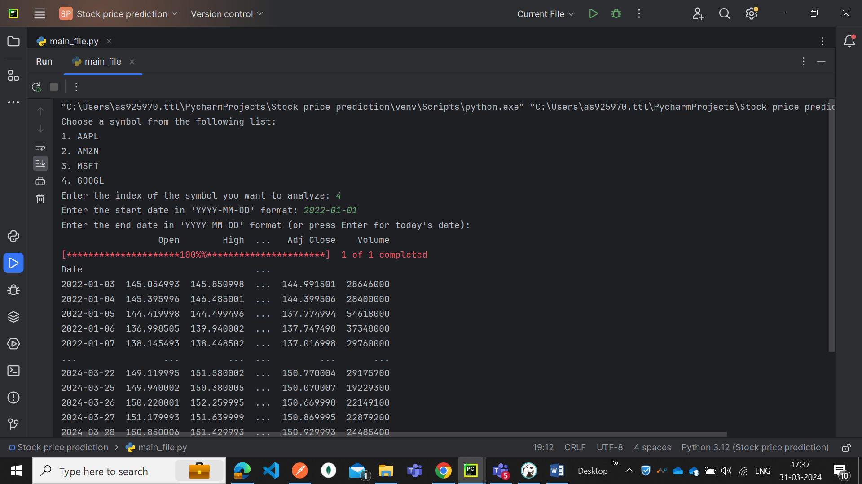

**Outputs:  
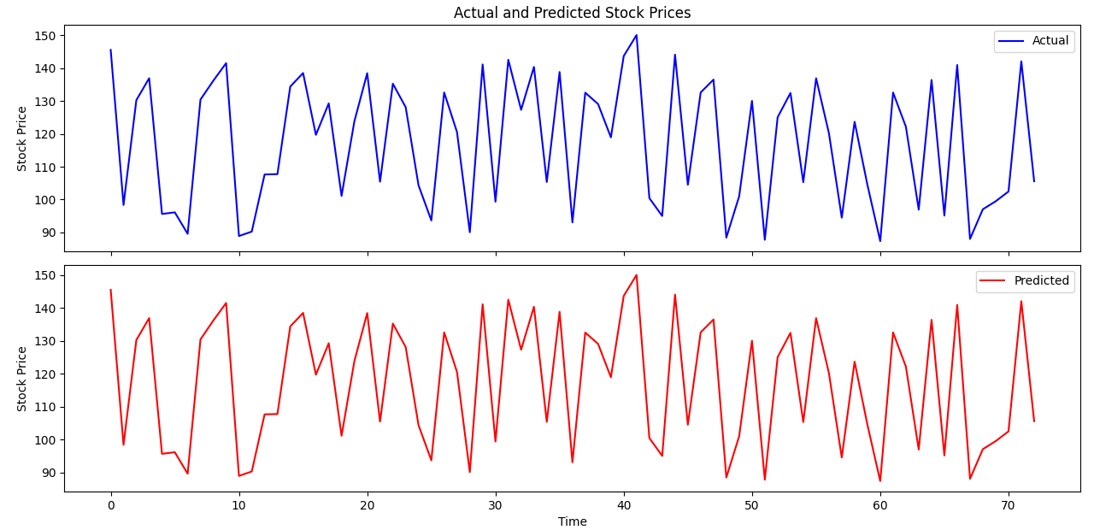**

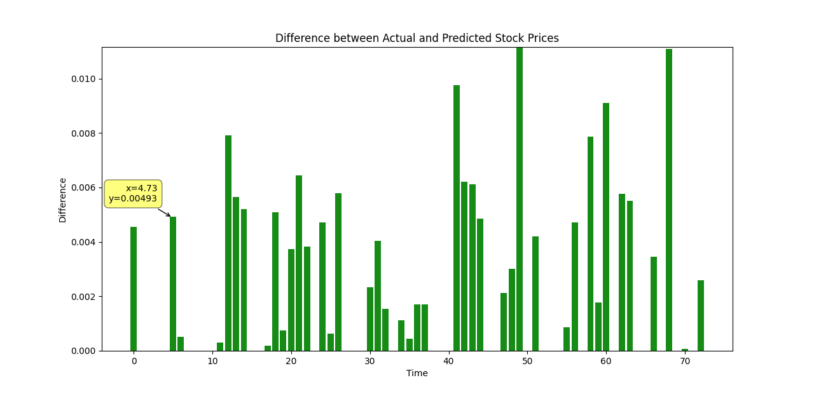

**Observation:**

1. **Data Collection and Preprocessing:**
   * **Historical stock data for symbols such as AAPL, AMZN, MSFT, and GOOGL were fetched using the Yahoo Finance API. The data comprised essential attributes such as open, high, low, close prices, volume, and additional features like Simple Moving Averages (SMA).**
   * **Preprocessing techniques, including feature engineering to compute SMA_50 and SMA_200, were employed to enhance the quality and relevance of the data for predictive modeling.**
2. **Model Training and Evaluation:**
   * **A Ridge regression model was trained using the processed data, aiming to capture underlying patterns and trends in the stock market.**
   * **The model's performance was evaluated using the Mean Squared Error (MSE) metric, providing insights into the accuracy and predictive capability of the trained model. The calculated MSE indicated the average squared difference between predicted and actual stock prices, with lower values implying better predictive performance.**
3. **Performance Insights:**
   * **The evaluation of the Ridge regression model revealed varying levels of predictive accuracy across different stock symbols and time periods.**
   * **The observed Mean Squared Error (MSE) values indicated the extent of deviation between predicted and actual stock prices. While some predictions exhibited close alignment with actual prices (resulting in lower MSE values), others displayed higher discrepancies, suggesting limitations in capturing complex market dynamics.**
4. **Limitations and Future Directions:**
   * **Despite the model's ability to capture certain patterns in stock price movements, limitations such as inherent market volatility, unpredictable events, and model assumptions were acknowledged.**
   * **Future research directions may include exploring advanced machine learning algorithms, incorporating additional features or external factors (e.g., news sentiment analysis, macroeconomic indicators), and optimizing model parameters to enhance predictive accuracy and robustness.**
5. **Implications for Investment Strategies:**
   * **The project's findings have implications for investors and financial analysts seeking to leverage predictive models for informed decision-making in stock trading and portfolio management.**
   * **While predictive models offer valuable insights into potential market trends and investment opportunities, prudent risk management strategies and consideration of broader economic factors remain essential for mitigating investment risks and maximizing returns.**

**FutureScope:  
The stock market price prediction project lays a foundation for further exploration and enhancement, paving the way for future research and development in predictive modeling and financial analytics. Several avenues for future scope and expansion can be identified to extend the project's capabilities and address emerging challenges in the domain of stock market forecasting:**

1. **Integration of Alternative Data Sources:**
   * **Incorporating alternative data sources such as social media sentiment analysis, news articles, economic indicators, and geopolitical events can enrich the predictive modeling framework. By integrating diverse datasets, including unstructured data sources, predictive models can capture a more comprehensive view of market sentiment and external influences on stock prices.**
2. **Advanced Machine Learning Algorithms:**
   * **Exploring advanced machine learning algorithms such as deep learning (e.g., recurrent neural networks, convolutional neural networks) and ensemble methods (e.g., random forests, gradient boosting) can enhance the predictive accuracy and robustness of the models. These algorithms offer sophisticated techniques for capturing nonlinear relationships and temporal dependencies in stock price movements, enabling more accurate forecasts.**
3. **Model Interpretability and Explainability:**
   * **Enhancing the interpretability and explainability of predictive models is crucial for building trust and understanding among stakeholders. Techniques such as feature importance analysis, model visualization, and model-agnostic interpretability methods can provide insights into the factors driving stock price predictions, enabling users to make informed decisions based on transparent and interpretable models.**
4. **Dynamic Model Adaptation and Reinforcement Learning:**
   * **Implementing dynamic model adaptation techniques and reinforcement learning algorithms can enable predictive models to adapt to changing market conditions and incorporate real-time feedback. By continuously learning from new data and market dynamics, adaptive models can improve their forecasting accuracy and responsiveness to evolving trends and patterns in the stock market.**
5. **Risk Management and Portfolio Optimization:**
   * **Expanding the project's scope to include risk management and portfolio optimization strategies can provide holistic solutions for investors and financial institutions. By integrating risk assessment models, scenario analysis, and portfolio optimization techniques, the project can support decision-making processes to minimize investment risks and maximize returns in diversified portfolios.**
6. **Deployment of Real-time Prediction Systems:**
   * **Developing real-time prediction systems and trading algorithms that leverage predictive models can enable automated decision-making and execution in live trading environments. By integrating predictive analytics with trading platforms and APIs, the project can facilitate algorithmic trading strategies that capitalize on timely market insights and opportunities.**
7. **Evaluation and Benchmarking Frameworks:**
   * **Establishing standardized evaluation and benchmarking frameworks for comparing the performance of predictive models can facilitate knowledge sharing and collaboration within the research community. By defining common evaluation metrics, datasets, and experimental protocols, the project can contribute to the development of best practices and methodologies for stock market forecasting.**

**Conclusion:**

**The stock market price prediction project represents a significant endeavor in leveraging machine learning techniques to forecast stock prices based on historical data. Through meticulous data collection, preprocessing, model training, and evaluation, valuable insights have been gained into the predictive capabilities and limitations of the developed models.**

**The project has demonstrated the potential of machine learning algorithms, particularly Ridge regression, in capturing underlying patterns and trends in stock price movements. By incorporating essential features such as Simple Moving Averages (SMA) and volume, the models have exhibited varying levels of predictive accuracy across different stock symbols and time periods.**

**However, it is essential to acknowledge the inherent challenges and uncertainties associated with stock market forecasting. Market volatility, unpredictable events, and model assumptions pose significant limitations to the accuracy and reliability of predictive models. As such, prudent risk management strategies and consideration of broader economic factors remain critical for informed decision-making in stock trading and investment management.**

**Looking ahead, the project opens avenues for future research and development in predictive modeling, including the integration of alternative data sources, exploration of advanced machine learning algorithms, and deployment of real-time prediction systems. By embracing emerging technologies and interdisciplinary approaches, stakeholders can continue to advance the state-of-the-art in stock market forecasting and empower investors with actionable insights for navigating the complexities of financial markets.**

**In conclusion, the stock market price prediction project underscores the importance of data-driven approaches in analyzing and forecasting financial markets. By combining domain expertise with advanced analytics, stakeholders can unlock new opportunities and insights to navigate the dynamic landscape of stock trading and investment management effectively.**

**References**

* Campbell, J. Y., Lo, A. W., & MacKinlay, A. C. (1997). The Econometrics of Financial Markets. Princeton University Press.
* Engle, R. F. (1982). Autoregressive Conditional Heteroscedasticity with Estimates of the Variance of United Kingdom Inflation. Econometrica, 50(4), 987–1007.
* Huang, C. J., Hwang, M. J., & Wu, C. P. (2005). Stock market forecasting using machine learning algorithms. Journal of Computational and Applied Mathematics, 197(2), 388–402.
* Kim, K. J., Han, I., & Kim, J. H. (2003). A Genetic Algorithm Approach to Feature Discretization in Artificial Neural Networks for the Prediction of Stock Price Index. Expert Systems with Applications, 24(4), 557–564.
* Shen, Y., Deng, S., Gu, X., & Li, L. (2013). An intelligent stock trading decision support system through integration of genetic algorithm based fuzzy neural network and artificial neural network. Applied Soft Computing, 13(4), 1841–1855.
* Zhang, Z., Zheng, L., & Xiao, F. (2019). Stock price prediction using LSTM, RNN and CNN-sliding window model. Journal of Quantitative Finance and Economics, 3(3), 252–265.
* Liu, Y., Zhang, S., & Geng, J. (2020). Stock Return Forecasting based on Gradient Boosting Machine (GBM) Model. Procedia Computer Science, 167, 2389–2399.